YD-CS Transistor test specification
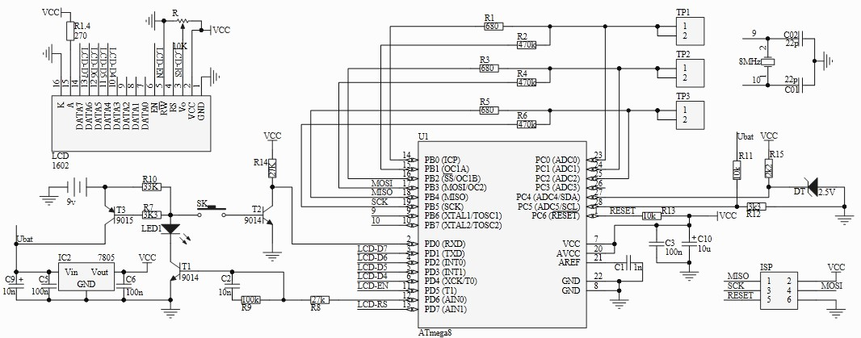
1. Circuit diagram

2. PCB components follow this diagram view of a mounting components: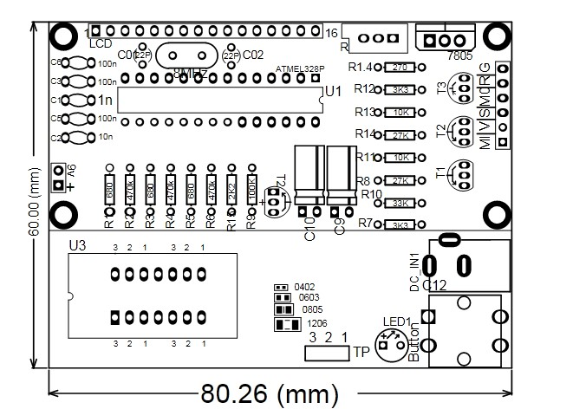
3. Detailed list of components
element | Serial number | specifications | note
1 resistance | R2, R4, R6 | 470kΩ 1% | Huang zi black orange brown
2 resistance | R1, R3, R5 | 680Ω 1% | Blue grey black and brown
3 resistance | R15 | 2K2 1% | Red and black brown brown
4 resistance | R1.4 | 270Ω 1% | Red purple black and brown
5 resistance | R12, R7 | 3K3 1% | Orange orange dark brown, brown,
6 resistance | R13，R11 | 10K 1% | Brown black, black and brown
7 resistance | R14，R8 | 27K 1% | Red violet black and brown
8 resistance | R10 | 33K 1% | Orange orange red, brown
9 resistance | R9 | 100K 1% | Brown, black and orange brown
10 crystals | 8MHZ | 8MHZ | nonpolar
11 Rows of pinhole | —— | 16Pin | 2.54 spacing, plug-in
12Adjustable resistance | R | 10K (103) | Place according to the graph
13 Voltage chip | WS78L05 | WS78L05 TO-92 | Place according to the graph
14 triode | T1，T2 | S8050 TO-92 | Place according to the graph
15 triode | T3 | S8550 TO-92 | Place according to the graph
16 Zener diode | DT | LM336Z25 TO-92 | Place according to the graph
17 Power terminal | DS_9V | The DC plug | Place according to the graph
18 Key switch | Button | Touch your keys | Cap with a button
19 LED | LED1 | Yellow LED | Long is short negative
20 capacitance | C9，C10 | 10uf electrolytic capacitor | White is negative
21 IC lock block | U3 | 14 p lock block IC | dual-in-line
22 IC low seat | U2 | 28P | dual-in-line
23 capacitance | C3，C5，C6 | 104 100nf | nonpolar
24 capacitance | C1 | 102 1nf | nonpolar
25 capacitance | C2 | 103 10uf | nonpolar
26 r ATMEGA328P-PU | U2 | ATMEGA328P-PU | Place according to the graph
27 capacitance | C7，C8 | 22PF 50V | nonpolar
4. Soldering reference step：
4.1 Soldering components from low to high, the first welding resistance, which try to stick flat PCB, neat appearance, unified direction;
4.2 After Soldering 8MHZ crystal, then soldered on both sides of 22pf capacitance;
4.3 Then, the Soldering C6, C3, C1, C5, C2 capacitor row, and then Soldering U2 IC seat;
4.4 Then soldered LED1, T1, T2, T3,7805, soldering C10, C9, DT, R (adjustable resistance), LCD1;
4.5 Finally, Soldering 14PIN IC Block, 9V power outlets, key switch;
4.6 Soldered each step, you can cut Component pin.
5.Function realization：
5.1 a key measurement operation, auto power off delay. Shutdown current is only 20nA, support for battery operation.
5.2 Automatic detection PNP and NPN bipolar transistor, N, P-channel MOSFET, JFET field effect transistors, diodes, two diodes, thyristors, resistors, capacitors, inductors. Automatic detection pin definitions.Current amplification factor (B)
5.3 Measurement bipolar transistor and the emitter of the turn-on voltage (Uf). Darlington transistor can be identified by the amplification factor of the high threshold voltage and high current.
5.4 can detect bipolar transistors and MOSFET protection diode inside and displayed on the screen.
5.5 measured threshold voltage and gate capacitance of the MOSFET.
5.6 supports two measuring resistors, potentiometers can also be measured. If the potentiometer is adjusted to its end, the tester can not distinguish between the middle and the ends of the pins.
5.7 The resolution of the resistance measurement is 0.1 ohms and the highest measured value is 50M ohms.
5.8 Capacitance measurements range from 25pf to 100mF (100 thousand UF). Resolution up to 1 pF, inductance measurement range of 0.01MH-20H, less than 0.01MH will be displayed as a resistor.
5.9 The equivalent series resistance (ESR) of the capacitor above 2UF can be measured with a resolution of 0.01 ohms. This feature is very important for the detection of capacitive performance.
5.10 Two diodes can be displayed in the correct direction of the symbol, while showing the forward voltage drop.
5.11 LED is detected as a diode, the forward voltage drop is higher than the normal value. Dual LED detection for dual diode. Detection of light emitting diode will shine.
Note:
1. For the first time, after electrify, please adjust the side of a 103 blue and white adjustable resistance make the LCD screen lights up.
2. Remember that 9 v dc power supply, the power of positive and negative don't wrong.
3. Remember that before the measurement of capacitance, to discharge, otherwise damage the chip.
4. 1, 2, 3, as a set of measurement point, measuring just pick any two or three points.

