Multi-function wireless Bluetooth audio installation manual
Bluetooth reception, hands-free calls, can be forwarded back, card MP3 player, AUX function, radio function
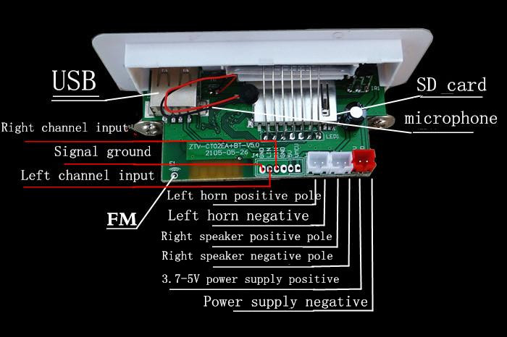
【installation】
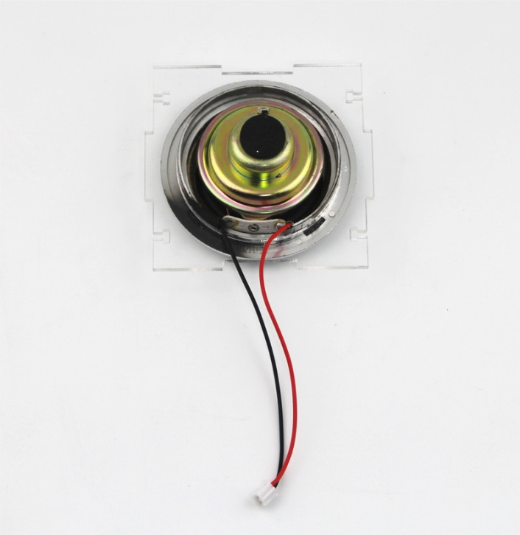
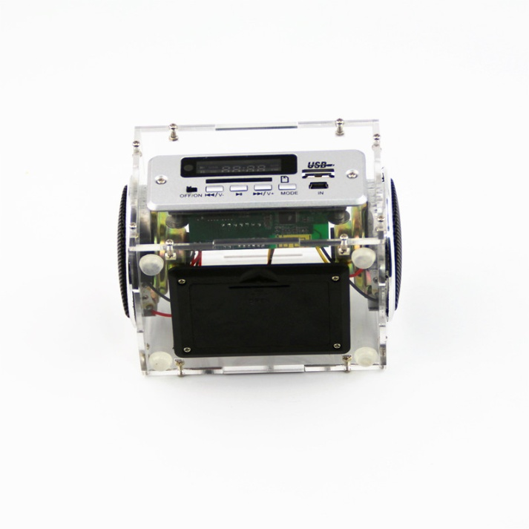
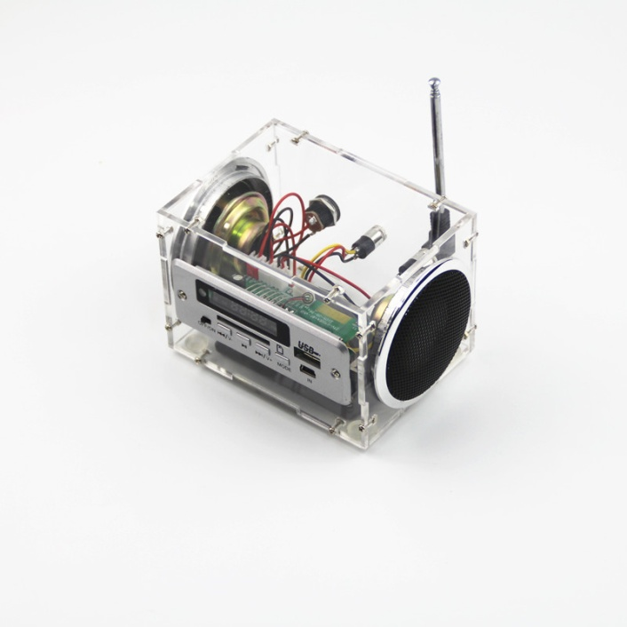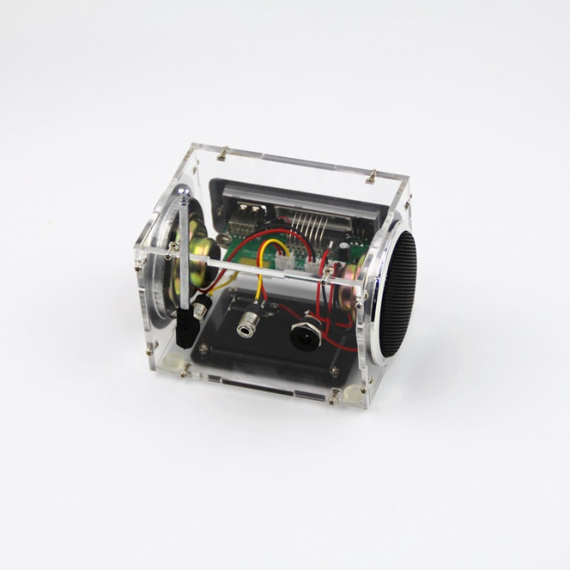
Metal cover 4 black protruding metal pieces pressed toward the yellow arrows flattened
Power supply, charging jack
Radio antenna jack
4
3
2
1
75MM
105MM
77MM
Audio input jack
Horn circle around can add a little glue fixed more solid

The positive electrode of the torch is welded
Speaker negative welding black line
BL-5C lithium battery installation box
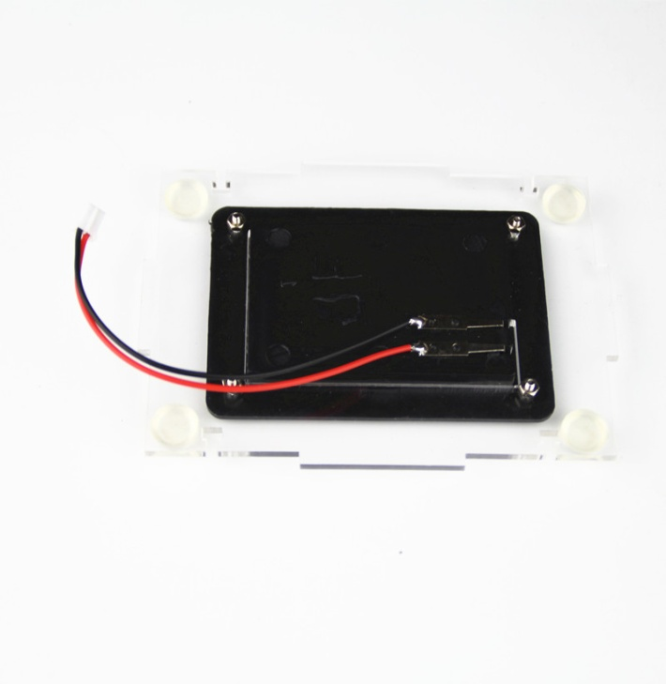
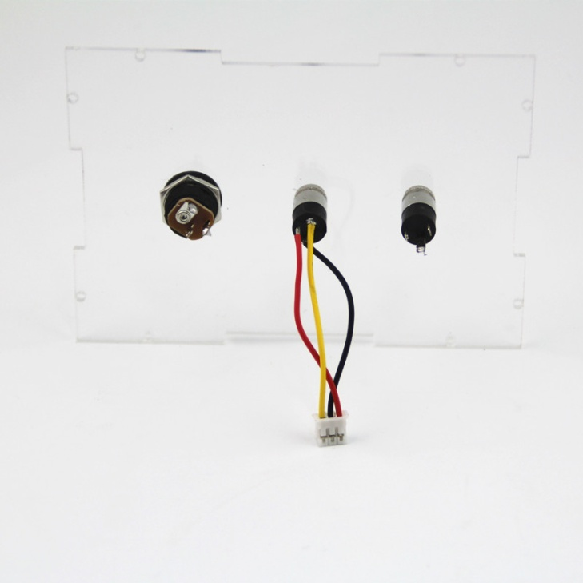
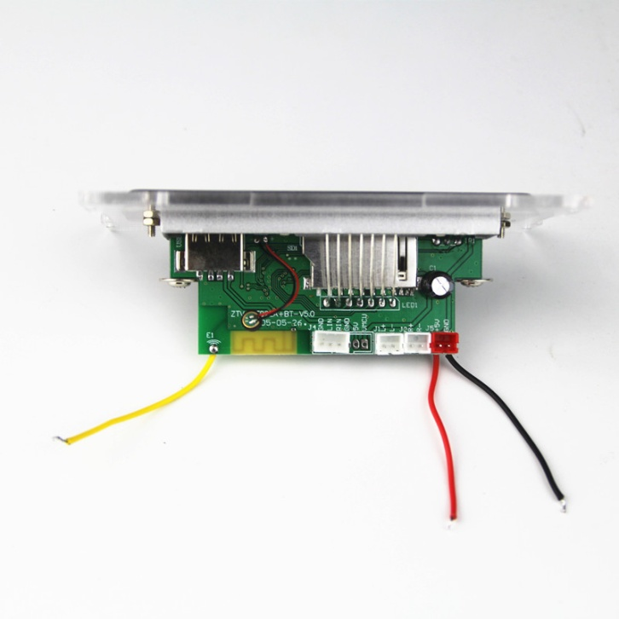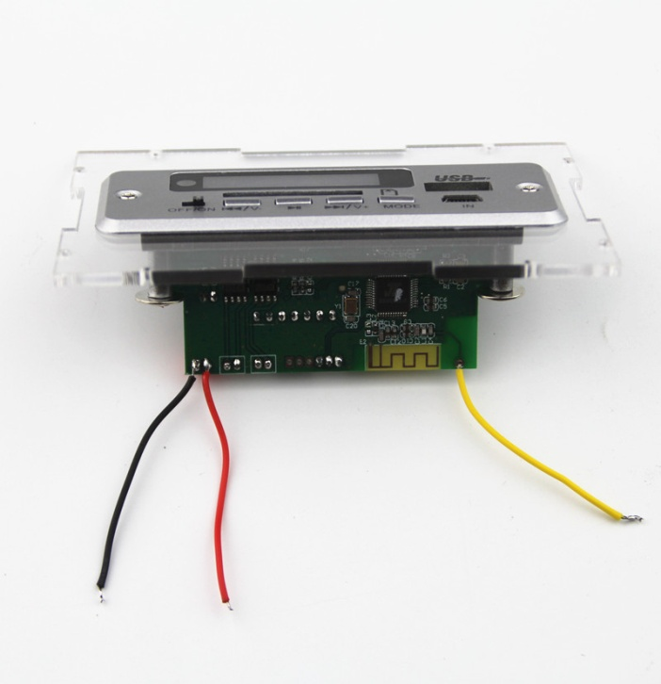
The longest pin is connected to the antenna terminal yellow line
The longest pin then red line, yellow and black line arbitrary access
Red, black wire welding in the back of the terminal, between the solder joints must not be shorted
The right side of the welding negative black line
The left side of the welding positive red line
Yellow wire soldering radio antenna port
Use two 2 * 8mm screws
8
7
6
5
Take the black line
Maximum terminal welding red line

The middle of the jack can not be lost

Welding black line
Take the red line

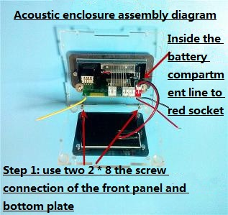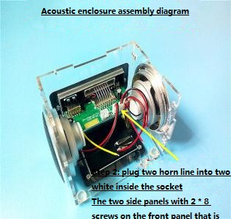
1000
9
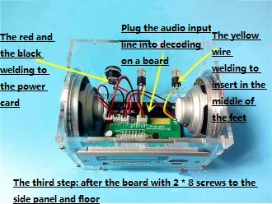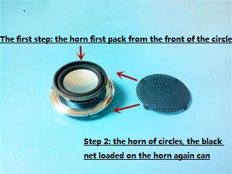
11
12
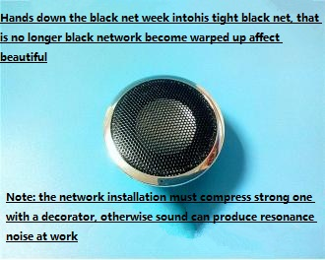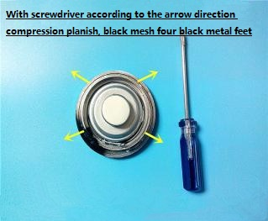
14
13
注意事项：
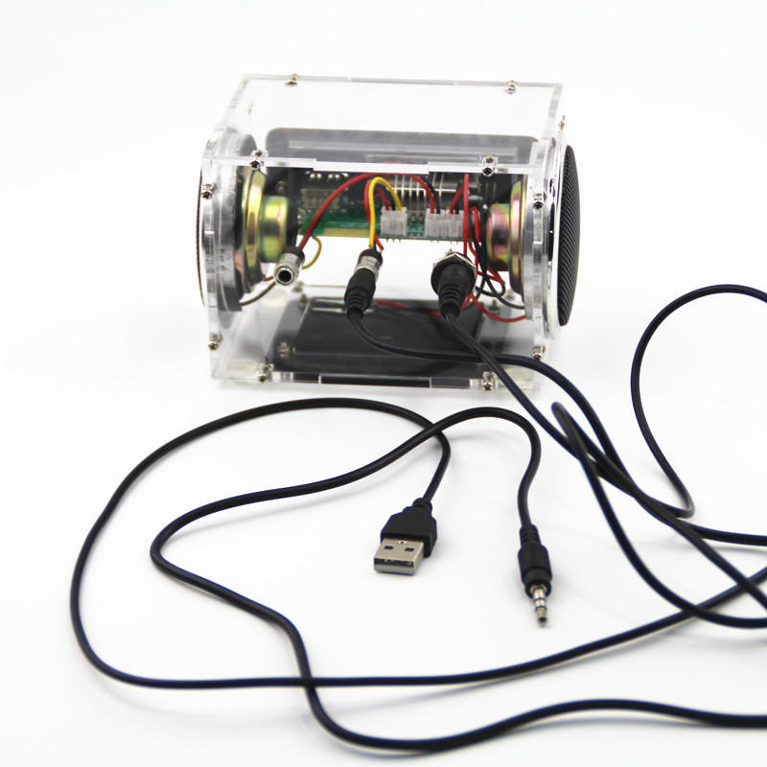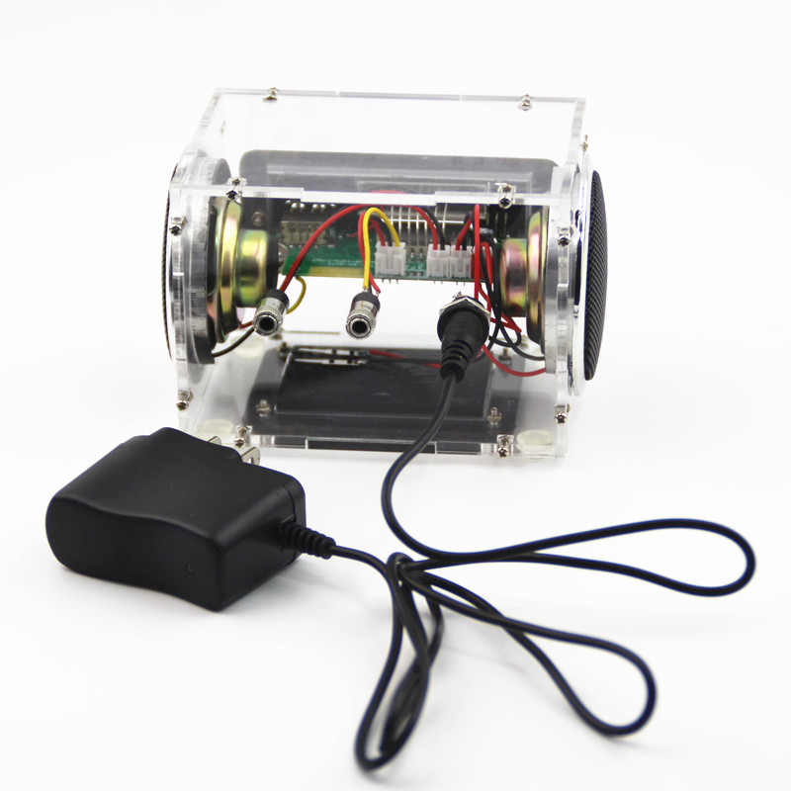
3.5MM audio head can be an external audio equipment
Charge the special charger when inserted
Internal battery charging must use 4.2V dedicated charger, millions of access 5V power supply
In the case of no battery sound, you can external 5V DC power supply

【Instructions for use】
1. Switch machine:
OFF / ON power switch: false shutdown (uninterruptible case, only turn off the panel switch, will maintain low power consumption)
Power on: Turn the power switch to the "ON" position;
Shutdown: Set the power switch to the "OFF" position
2.MP3 playback:
Boot state to insert a copy of the MP3 song U disk or SD card, the machine will automatically identify and play, play MP3 button function as follows:
"On a song": short press to play on a song, long press the volume minus;
"Play / Pause": press the first pause is playing the song, press again to restore the playback state;
"Next song": short press to play the next song, long press the volume plus;
"MODE": machine work mode selection, switch SD card, U disk, clock, FM, Bluetooth, LINE mode;
3.FM mode:
Use the "MODE" key to switch the machine to the FM state. "Play / pause": short press to automatically search and store the radio; "next song": short press from low to high search for radio, Long press for volume plus.
4.LINE mode:
Press "MODE" on the panel to switch the machine to "LINE". The sound source is input from "LINE / DC", the volume is controlled by an external source device, and the volume can also be adjusted by "Previous" and "Next". The adjustment method is also the same as the MP3 volume adjustment.
5. Clock regulation:
Press "MODE" on the panel to switch to the "clock" state, press the "Play / Pause" button to select the time or minute, then select the part of the flash, then press "Previous" or "Next" adjustment time The (Note: after each boot to re-adjust the time)
6. Bluetooth mode:
Press the "MODE" on the panel to switch the machine to "bLUE" state, open the audio device with Bluetooth function, search for "ZTV-CT02EA" and connect it, the volume can be controlled by an external source device, One "and" next "to adjust the volume; phone call short press" play / pause "to answer the phone long press for the refusal.
When the call is on or the call is short, press "Play / Pause" to hang up.

